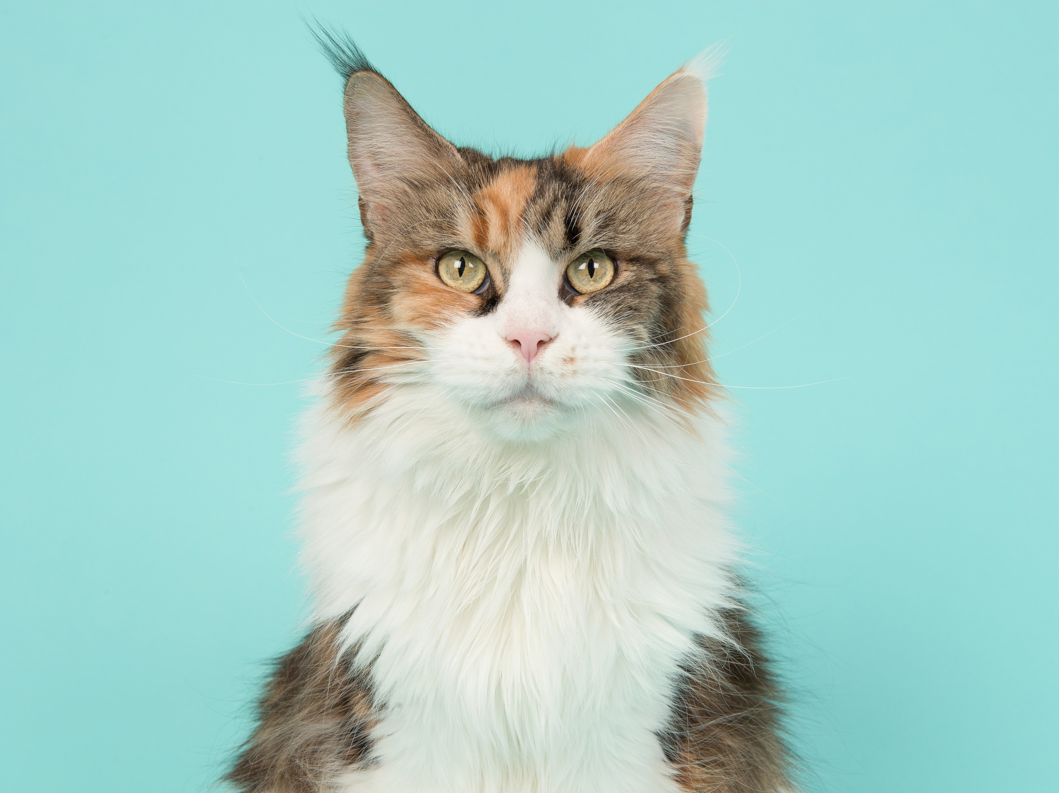 |  | [pets name]  [breed]  [age]  [sex]  [weight]
[pets name] Qualifications  Microchip Number: [insert number]  Desexed: [date desexed]  Vaccinated: [last vaccination date]  Registration Number: [insert number]  Owner details  Name:  [Owner name]  Number:  [contact number]  EMAIL:  [email@email.com.au]  Please feel free to contact us for any further questions! |  | About  [Answer questions here such as:  How long have you owned your pet?  Did your pet have a previous owner?  Is your pet adopted?  Does your pet shed?  Is your pet an indoor or outdoor pet or both?  Do you walk them regularly?  Do you take your pet to exercise?  How often do you get them groomed?]  Training  [Answer questions here such as:  Do you take them to a pet daycare?  Is your pet house/ toilet trained?  Has your pet received formal training?  Does your pet know any special tricks?]  References  Veterinarian  Name: [Insert name]  Contact Number: [insert number]  Previous Landlord/ Property Manager  Name: [insert name]  Contact Number: [insert number]

